2024
Board Members

100 Opa Locka Blvd. Mia, FL 33054
www.mdcfapa.org * mdcfapa@gmail.com
shabenj@aol.com *
travis.davis33@yahoo.com

Travis Davis,
President
Barbara Johnson,
Vice President
Joann Jones,
Corresponding Secretary
Ethel Rivers,
Treasurer
Cynthia Hughes,
Parliamentarian
Elizabeth Brooks,
Chaplain
Lily Rodgriguez,
Board Member At Large

Lashoan Singleton,
Board Member At Large

Shamele Jenkins,
Executive Director
& Immediate Past President
(305) 469-1157
MDCFAPA is open to ALL
co-parents (foster, adoptive, & kinship, non-relative caregivers and biological parents) in Miami Dade County as well as those interested in being advocates of our mission

SPECIAL ZOOM MTG
“PARENTING IN 2024
THE MODERN PARENT
PART #1”
TUES., APRIL 9TH
7:00pm – 9:00pm
Meeting ID: 810 9918 3770

Security Passcode: 699222

Registration Link:
https://us02web.zoom.us/meeting/register/tZUtfuCppjgtHdQSc5YLG02uHq70eDBhBGG-

Learn tips
how to relate to youth in 2024
What you were taught growing up is different from today’s times!!!
Old tactics for childrearing do NOT work
Learn new skills
Learn how to watch
Learn how to listen
2 hrs. of in-service training
SPECIAL ZOOM MTG
“PARENTING IN 2024
THE MODERN PARENT
PART #2
3th Saturday Meeting
SAT.
APRIL 20, 2024
10:30am – 12:30pm
2.0 hrs in-service training hours

Learn signs & symbols on the internet
learn what tattoos & hidden figures
Human trafficking

Meeting ID: 836 9568 9554

Security Passcode: 056157

Registration Link:

https://us02web.zoom.us/meeting/register/tZcrfuyupjIvH9B9gAn8XWr97c1l13kpJW1O

FLORIDA HB3
Florida Gov. Ron DeSantis signed a bill on March 25th that will prohibit children younger than 14 from joining social media in the state. Those who are 14 or 15 will need a parent’s consent before they join a platform.
EFFECTIVE JANUARY 2025!
The bill, HB3, also directs social media companies to delete the existing accounts of those who are under 14. Companies that fail to do so could be sued on behalf of the child who creates an account on the platform. The minor could be awarded up to $10,000 in damages, according to the bill. Companies found to be in violation of the law would also be liable for up to $50,000 per violation, as well as attorney’s fees and court costs.

YES
We’re going to the Bahamas
for fun & visit Group Homes
Thurs. Aug. 1 – Mon. Aug. 5th
Info: Christina Thatcher
@ AAA
305-908-4676
Shamele - 305-469-1157

****************
JOIN US
THURS. APRIL 4TH at 7:30pm
Actor’s Playhouse
280 Miracle Mile,
Coral Gables
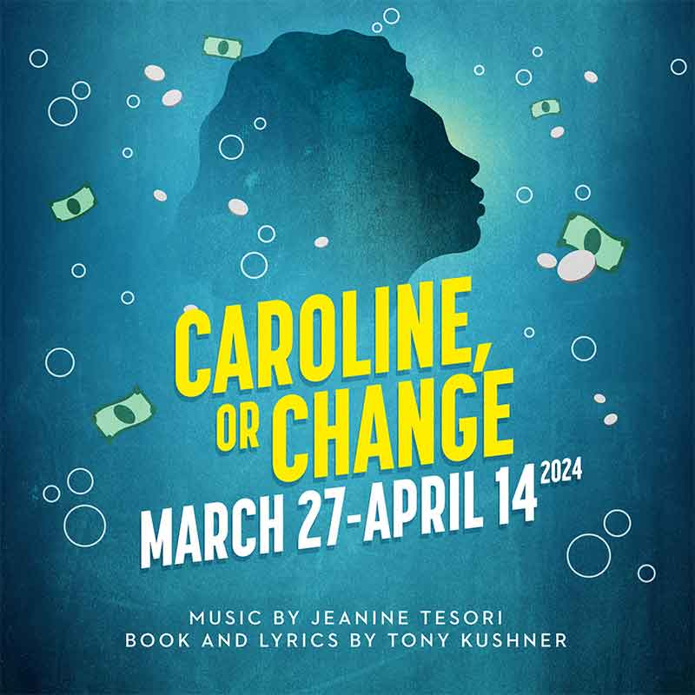
RSVP: 305-474-0078 Leave your name & tele, # of tickets needed
EMPRESS & QUEENS MOTHERS’ BREAKFAST
(for all our adoptive, foster & relative care mothers)
Saturday,
APRIL 27, 2024
8:30am – 11:30am
Golden Corral Restaurant
33525 South Dixie Hwy
Florida City, FL 33034

Cost: $15.00pp
for MDCFAPA members
( first 50 mothers pay in advance)
$20.00 afterwards

Cost: $15.00pp nonmembers

Pay: www.mdcfapa.org
Or
Cash App: $ShameleJenkins
- Speakers & Entertainment
- All You Can Eat
- Networking & Door Prizes
”SCHOOL DATES”
MIAMI DADE PUBLIC SCHOOL
April 10: - Teacher planning day; no students in school;
May 26: Memorial Day; holiday for students and employees
June 5: Last Day of School
HOTLINES

Foster Placement Line
(305) 810-1004
Citrus FCN Incident Report Hotline 305-445-1055
Placement On-Call/After Hours
305-810-1004

ADOPTION UNIT: ADOPTION SUBSIDY ISSUES, POST- HEALTH CARE AND MORE?
BBofill@citrusfcn.com
postadopt@citrusfcn.com
Katrella -786-521-6194
Sergio 786-501-5317
Madalina 786-817-7240
F. A. S. T. Foster Allegation Support Team 1-800-327-8119 * http://www.floridafapa.org

Florida Domestic Violence Hotline 1-800-500-1119, Florida Relay 711, TTY: 1-800-621-4202 Florida Sexual Violence information line 1-888-956-7273

National Suicide & Mental Health Pevention Hotline
9 8 8

DID YOU RENEW OR OBTAIN YOUR MDCFAPA 2024 FAMILY REGISTRATION?
Memberships is $25.00 per calendar year
Membership gets you
- Tickets to plays, concerts
- Movie premieres
- Private parties
- Distribution of foods, school
- Support & more
YOU ARE NOT ALONE! www.mdcfapa.org

